2020 Silver City
LiDAR and Airphoto
Data Capture and Processing

LiDAR and Air Photo Report

Our File:
2611 19372-06

Submitted To:

Highways and Public Works | Transportation Aviation Branch | W-16
T 867-455-2883 | Yukon.ca

And
Yukon Geomatics
Attention: Idrees Muhammad, P.Eng., M.Eng

Submitted By:
McElhanney Ltd.
200-858 Beatty Street
Vancouver, BC
V6B 1C1
Tel: (604) 424 4784
Contact: Azadeh Koohzare, PhD., PEng.

May 11, 2021

Table of Contents

1. Introduction 3
2. Mission Plan 3
3. Equipment 4
4. Flight Plan 5
5. Data Processing 7
6. Point Density 7
7. Calibration 8
8. Quality Control 9
9. Deliverables 9

List of Figures and Tables

Figure 1 Aerial survey ……………………………………………………………………….. 3
Figure 2 Optech Galaxy components ………………………………………………………. 4
Figure 3 Phase One components …………………………………………………………… 4

Table 1-3 Flight Parameters ………………………………………………………………… 5

Introduction

McElhanney Ltd (MCSL) performed a LiDAR and aerial photography acquisition for Silver City, shown in Figure 1.

The site was flown on July 31st, 2020. This report describes the acquisition, post-processing and quality control methodology used to produce the final elevation models.

Mission Plan

Project: Silver City LiDAR and Aerial photo Project
Date: 2020-07-31
Location: Silver City
Topography: low relief

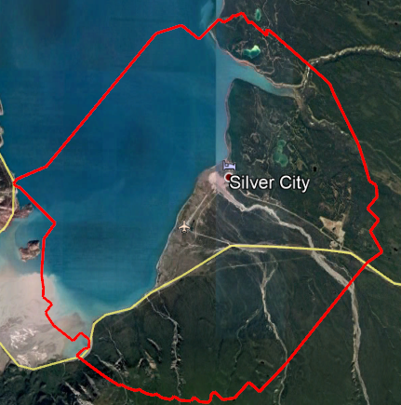
Figure 1– LiDAR Survey Site

Equipment

McElhanney utilized the Optech Galaxy system for LiDAR Capture (Figure 2).
For Product Specifications of Optech Galaxy please see

http://www.teledyneoptech.com/index.php/product/optech-altm-galaxy/
The Galaxy was mounted on Piper Navajo fixed wing Aircraft.
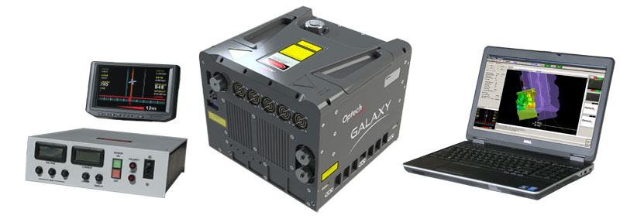Figure 2 – Optech Galaxy components

On Board Camera Phase One iXU-RS1000 RGB simultaneous capture (Figure 3.)

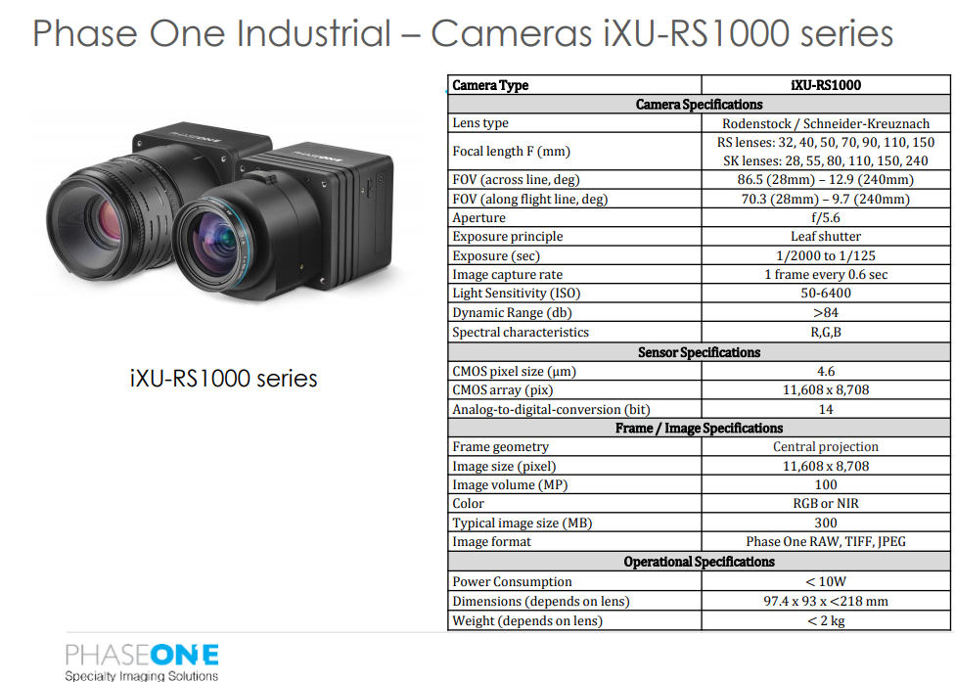
Figure 3 – Phase One Camera Series

Flight Plan

Table 1: Flight Parameters- 2020-07-31
Strip ID | Start [s] | Stop [s] | Duration [s] | PRF [kHz] | Scan Frequency [Hz] | Scan Swath [deg] | Speed Avg [m/s] | Height Avg [m]
1 | 502366.2 | 502381.7 | 15.5 | 400 | 66 | 50.0 | 75.4 | 2547.6
2 | 502507.2 | 502560.0 | 52.8 | 400 | 66 | 50.0 | 73.1 | 2528.6
3 | 502663.0 | 502739.2 | 76.1 | 400 | 66 | 50.0 | 78.1 | 2452.7
4 | 502846.0 | 502945.4 | 99.4 | 400 | 66 | 50.0 | 78.4 | 2337.5
5 | 503032.6 | 503154.5 | 121.9 | 400 | 66 | 50.0 | 79.7 | 2278.4
6 | 503249.2 | 503367.3 | 118.1 | 400 | 66 | 50.0 | 74.1 | 2296.5
7 | 503436.8 | 503561.4 | 124.6 | 400 | 66 | 50.0 | 79.8 | 2260.4
8 | 503666.4 | 503801.3 | 134.9 | 400 | 66 | 50.0 | 69.0 | 2287.8
9 | 503881.1 | 504006.6 | 125.6 | 400 | 66 | 50.0 | 80.3 | 2189.9
10 | 504066.8 | 504211.0 | 144.3 | 400 | 66 | 50.0 | 69.7 | 2142.8
11 | 504302.0 | 504435.0 | 133.0 | 400 | 66 | 50.0 | 76.8 | 2155.4
12 | 504500.8 | 504645.1 | 144.2 | 400 | 66 | 50.0 | 68.4 | 2151.9
13 | 504753.7 | 504889.6 | 135.9 | 400 | 66 | 50.0 | 75.2 | 2142.4
14 | 505000.1 | 505124.8 | 124.6 | 400 | 66 | 50.0 | 75.8 | 2184.0
15 | 505199.0 | 505284.4 | 85.4 | 400 | 66 | 50.0 | 79.1 | 2224.0
16 | 505388.4 | 505501.9 | 113.5 | 400 | 66 | 50.0 | 77.8 | 2234.1
17 | 505583.5 | 505640.9 | 57.4 | 400 | 66 | 50.0 | 80.5 | 2185.4
18 | 505731.9 | 505846.3 | 114.4 | 400 | 66 | 50.0 | 67.1 | 2268.1
19 | 505989.5 | 506098.3 | 108.8 | 400 | 66 | 50.0 | 82.6 | 2159.6
20 | 507524.8 | 507669.1 | 144.3 | 400 | 66 | 50.0 | 74.7 | 1883.2
21 | 507865.5 | 507925.8 | 60.3 | 400 | 66 | 50.0 | 79.3 | 2151.9
22 | 508050.3 | 508124.6 | 74.2 | 400 | 66 | 50.0 | 83.1 | 1989.3
23 | 508230.4 | 508335.5 | 105.1 | 400 | 66 | 50.0 | 77.0 | 1937.2
24 | 508454.5 | 508550.2 | 95.7 | 400 | 66 | 50.0 | 77.1 | 1910.3
25 | 508675.6 | 508787.2 | 111.6 | 400 | 66 | 50.0 | 81.2 | 1920.2
26 | 508873.5 | 509014.0 | 140.5 | 400 | 66 | 50.0 | 77.0 | 1885.2
27 | 509082.6 | 509222.2 | 139.6 | 400 | 66 | 50.0 | 70.5 | 1930.0
28 | 509297.3 | 509444.3 | 147.0 | 400 | 66 | 50.0 | 74.5 | 1873.6
29 | 509508.2 | 509631.9 | 123.7 | 400 | 66 | 50.0 | 80.8 | 1905.2
30 | 509722.9 | 509866.2 | 143.3 | 400 | 66 | 50.0 | 77.3 | 1874.3
31 | 509934.7 | 510074.3 | 139.6 | 400 | 66 | 50.0 | 74.1 | 1913.1
32 | 510145.7 | 510306.7 | 161.0 | 400 | 66 | 50.0 | 69.1 | 1872.7
33 | 510370.6 | 510512.1 | 141.4 | 400 | 66 | 50.0 | 76.4 | 1866.6
34 | 510588.1 | 510750.1 | 162.0 | 400 | 66 | 50.0 | 68.9 | 1866.5
35 | 510831.7 | 510973.1 | 141.5 | 400 | 66 | 50.0 | 77.8 | 1834.0
36 | 511144.3 | 511249.4 | 105.1 | 400 | 66 | 50.0 | 67.9 | 1813.0
37 | 511348.7 | 511487.4 | 138.7 | 400 | 66 | 50.0 | 77.4 | 1836.3
38 | 511585.8 | 511751.5 | 165.7 | 400 | 66 | 50.0 | 67.5 | 1861.7
39 | 511812.6 | 511943.8 | 131.2 | 400 | 66 | 50.0 | 77.4 | 1842.6
40 | 512509.8 | 512606.5 | 96.7 | 400 | 66 | 50.0 | 82.5 | 2081.9
41 | 512732.9 | 512805.3 | 72.4 | 400 | 66 | 50.0 | 80.8 | 1992.1
42 | 512871.1 | 512988.2 | 117.2 | 400 | 66 | 50.0 | 78.8 | 2011.2
43 | 513077.3 | 513169.3 | 92.0 | 400 | 66 | 50.0 | 78.5 | 2002.9
44 | 513230.4 | 513353.2 | 122.8 | 400 | 66 | 50.0 | 78.9 | 1999.3
45 | 513419.8 | 513519.3 | 99.5 | 400 | 66 | 50.0 | 80.7 | 2014.9
46 | 513590.6 | 513720.0 | 129.3 | 400 | 66 | 50.0 | 79.3 | 2007.7
47 | 513810.9 | 513924.4 | 113.4 | 400 | 66 | 50.0 | 77.8 | 2026.4
48 | 513974.3 | 514105.4 | 131.2 | 400 | 66 | 50.0 | 75.5 | 2020.2
49 | 514174.9 | 514311.7 | 136.8 | 400 | 66 | 50.0 | 73.5 | 2119.4
50 | 514369.1 | 514505.8 | 136.8 | 400 | 66 | 50.0 | 74.3 | 2043.1
51 | 514578.1 | 514713.0 | 134.9 | 400 | 66 | 50.0 | 71.6 | 2152.7
52 | 514811.5 | 514944.5 | 133.0 | 400 | 66 | 50.0 | 79.1 | 2054.2
53 | 515031.7 | 515151.7 | 120.0 | 400 | 66 | 50.0 | 75.9 | 2164.6
54 | 515257.6 | 515386.0 | 128.4 | 400 | 66 | 50.0 | 80.1 | 2083.6
55 | 515469.5 | 515584.8 | 115.3 | 400 | 66 | 50.0 | 74.6 | 2192.8
56 | 515686.9 | 515777.1 | 90.1 | 400 | 66 | 50.0 | 75.8 | 2181.3
57 | 515897.9 | 516003.9 | 106.0 | 400 | 66 | 50.0 | 74.4 | 2200.2
58 | 516134.9 | 516202.7 | 67.7 | 400 | 66 | 50.0 | 77.2 | 2181.2
59 | 516344.0 | 516403.3 | 59.3 | 400 | 66 | 50.0 | 83.0 | 2085.4
60 | 516642.7 | 516646.9 | 4.2 | 400 | 66 | 50.0 | 71.6 | 2091.0
61 | 516737.0 | 516756.1 | 19.2 | 400 | 66 | 50.0 | 63.9 | 2103.4
62 | 516821.0 | 516852.3 | 31.3 | 400 | 66 | 50.0 | 82.4 | 2033.0
63 | 516929.2 | 516963.3 | 34.1 | 400 | 66 | 50.0 | 65.8 | 2070.5
64 | 517055.2 | 517094.9 | 39.7 | 400 | 66 | 50.0 | 75.9 | 2012.8
65 | 517158.8 | 517203.2 | 44.4 | 400 | 66 | 50.0 | 65.6 | 2045.2
66 | 517302.6 | 517337.6 | 35.0 | 400 | 66 | 50.0 | 75.5 | 2076.4
67 | 517449.1 | 517486.9 | 37.8 | 400 | 66 | 50.0 | 73.8 | 2046.4
68 | 517642.3 | 518104.8 | 462.5 | 400 | 66 | 50.0 | 82.5 | 2046.0
69 | 518437.5 | 518505.2 | 67.7 | 400 | 66 | 50.0 | 75.9 | 2118.0
70 | 518572.8 | 518607.0 | 34.1 | 400 | 66 | 50.0 | 77.3 | 2044.3
71 | 518725.0 | 518790.8 | 65.8 | 400 | 66 | 50.0 | 74.8 | 2060.4
72 | 518893.9 | 518970.0 | 76.1 | 400 | 66 | 50.0 | 70.6 | 2024.0
73 | 519055.4 | 519127.8 | 72.4 | 400 | 66 | 50.0 | 74.0 | 2037.4
74 | 519216.9 | 519245.4 | 28.5 | 400 | 66 | 50.0 | 71.4 | 2022.2

Data Processing

All GPS and IMU data was processed using PosPac MMS 8.4 software. The laser data was extracted using Teledyne Optech LMS software. The GPS antenna position in the airplane was calculated by post–processing the raw data at 1 second intervals for the entire flight.
We have used Precise Point Positioning (PPP) for the airborne GPS processing, and the coordinates were calculated in NAD83-CSRS.

The airborne positions were combined with the post–processed platform (aircraft) attitude information to generate a time tagged position and orientation solution.

The standard deviation of the airborne GPS solution for using KAR (Kinematics Ambiguity Resolution) was estimated to be 0.03, 0.04 and 0.05m in East, North and height directions, respectively.

The estimated values for the GPS antenna position were used with the laser ranges and platform angles to compute all the individual X, Y, and Z coordinates for each laser return in each flight line. The result is a processed point cloud containing all measured points.

Point Density

Bare earth point density varies with canopy closure, understory density and topographic features. Mean density of the point cloud was measured at nominal 12.31 pts/m² and the Bare earth point density was measured at nominal 4.53 pts/m².

Calibration

System: Optech ALTM Galaxy S/N 5060392
LiDAR Calibration flight:

Calibration Date: March 09, 2020 Location: Abbotsford, BC
The LiDAR system calibration was flown over calibration site. The lever arms (offset between GPS antenna IMU and Laser Mirror), were measured as:

Lever Arms
GPS Lever arms in (m):
X = 0.730 m Y = -0.465 m Z = -1.173 m

IMU Lever arms in (m):
x: 0 y: 0 z: 0

There were a total number of 10 flight lines for calibration: 9 basic orthogonal lines for LMS software analysis and 1 redundant line for better accuracy. The lines were planned as follow:

Flight line direction: 3 lines north – south and 3 lines east – west and 1-line NW-SE
All GPS with IMU data was processed using PosPac Applanix software v.8.3. and the laser data was extracted using LMS v.4.3 The GPS antenna position in the airplane was calculated by post–processing the raw data at 1 second intervals for the entire flight.

The calibration values used for this project are as follows:
imu_ex: 0.012695755 arcsec
imu_ey: -0.071263279 arcsec
imu_ez: -0.128636141arcsec

Quality Control

The LiDAR data consistencies have been checked between the flight lines using Terrascan software.

Comparison of Bare Earth LiDAR data with Ground Survey Values

According to ASPRS guidelines, the vertical accuracy of LiDAR is as follows:

= 0.023 m

Where the ”Check” refers to the ground truth ( In this project, we used survey points which are at least three times more accurate than the individual LiDAR points) and n is the number of check points. LiDAR data was checked vsground survey points. A total of 375 check points were used for this analysis.

Average dz -0.002
Minimum dz -0.065
Maximum dz +0.086
Average magnitude 0.018
Root mean square 0.023
Std deviation 0.023

Deliverables

Final output data is provided in NAD83CSRS UTM Zone 7 and the elevations are based on CGVD28 HT2 geoid model. The deliverables include:

- Bare Earth & Thinned model key points in las, xyz
- Non Bare Earth in las format
- Index map
- 15 cm Orthophto

